**Names: MWIMULE Bienvenu**

**Registration number: 224007968**

**Assignment of Entrepreneur-ship**

**PART I: DREAM IT**

**A. Describe your Dream**

**I. What is your dream for the future?**  
My dream is to become a world-class Penetration tester and IT innovator who builds advanced tools to secure digital systems and help organizations stay protected from cyber threats. I also want to educate others about digital safety and contribute to global cybersecurity development.

**II. Where do you want to be in the next 10 years in terms of your career?**  
In 10 years, I want to be leading a penetration firm with produce security services to the government and private sectors even to the society. Due to this growing late of cybercrimes pushes me into the field to think about it, and that aim will push me to the final destination of my goal, by helping people be update to the latest attacks and how to prevent and patch them. Not only leading the firm but also I want to create any academy school which teaches cyber security to teenagers and help them not to engage on cybercrimes just to prevent against them.

**III. Identify which of the words below describe your image in the future:**  
✔️ Successful  
✔️ Respected  
✔️ A Leader!  
✔️ Powerful

**B. Draw your Dream**

🟢 **Where I Am Now:**

* A passionate student in the field of **Penetration testing and Information Technology**
* Gaining hands-on experience in Python, networking, ethical hacking, and system security
* Learning tools like Kali Linux, Wireshark, and Metasploit, and Burpesuit for website penetration testing learning.
* Creating educational YouTube videos on cybersecurity and Python
* I have also started a youtube channel where I produce courses related to cybersecurity and how to use this technology in good way, in the way of starting the academy of cybersecurity, this is my channel (**https://youtube.com/@itbienvenu**)

🚧 **What I’ve Achieved So Far:**

* Built Python-based cybersecurity tools (e.g., password generators, email validators, password managers, multifactor authentication systems and even password encryption systems)
* Learned basics of Linux, penetration testing, like on web penetration testing and window penetration testing
* Started building a GitHub portfolio with security-related scripts, and this my github account link **(htpps://github.com/bienvenugashema**)
* Participating in online courses and CTFs to boost my skills, like on hackerone**(https://hackerone.com/gashcode)**

📈 **Steps I’m Taking Now:**

* Learning advanced cybersecurity topics like network programming, digital ciphers because the traditional one are now dead, advanced web security like creating intelligence systems using machine learning.
* Preparing for certifications (e.g., CEH, CompTIA Security+)
* Working on real-world projects to demonstrate my abilities, like I’m now creating a **cyber crate project** that will be a standalone free software that will be used by web developers to test their systems weakness and even software developers to test the vulnerability in their systems.
* Improving communication, leadership, and networking skills

🌟 **My Dream (End Goal):**

* Become a **world-class Penetration Tester**
* Work with global tech firms or start my own cybersecurity company
* Contribute to ethical hacking communities and train others
* Creating the cybersecurity academy in next ten yeasr
* Build innovative security tools that make the digital world safer

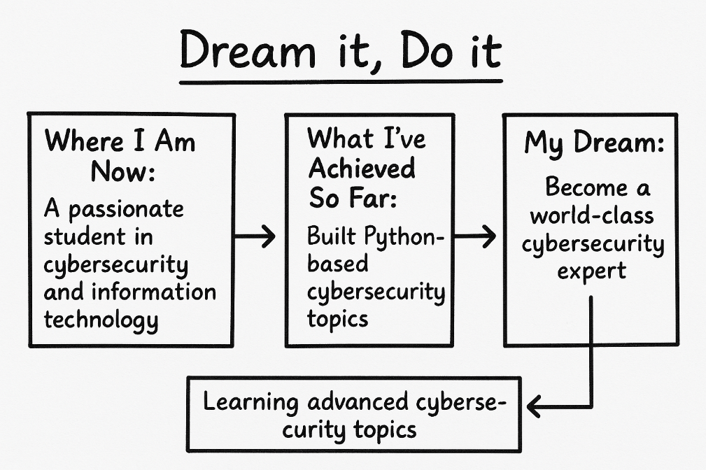

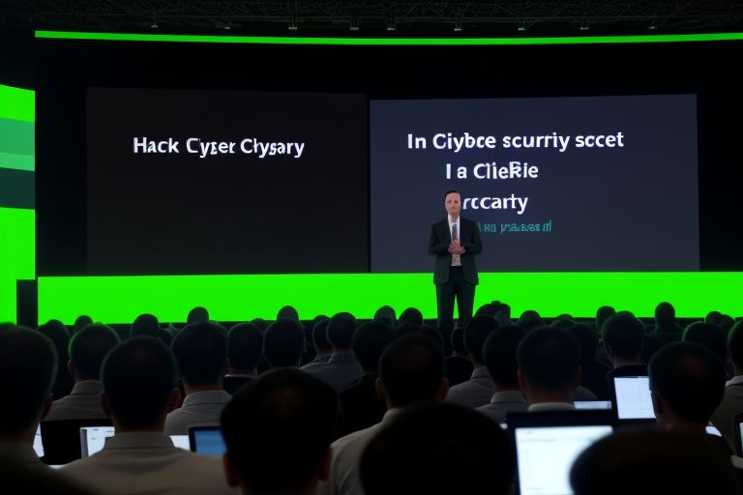

**I dream of standing on a global stage, sharing cutting-edge cybersecurity insights with experts from around the world. This is not just a dream — it's my mission. From learning how to hack ethically to building secure systems, my journey starts here, and this is the future I am building towards.**

**PART II: DO IT**

**A. Your Qualities – A SWOT Analysis**

**Strengths**

* Strong passion for technology and cybersecurity
* Fast learner with problem-solving mindset
* Knowledge of Python, networking, and ethical hacking tools
* Ability to implement what I have learnt to the real word problem
* Ability to work independently and stay focused

**Weaknesses**

* Limited real-world cybersecurity experience (still learning)
* Need to improve time management due to multitasking
* Problem of money, because many resources that should give me training require huge amount to enroll and that became a harder to me because I ’m still learning without any job.

**Opportunities**

* Growing demand for cybersecurity professionals
* Online platforms and certifications (e.g., CompTIA, CEH, etc.)
* Cybersecurity communities and tech conferences
* I can access internet without much cost, and I can access lab as we do in class we use this lab for free without any cost and everyone seems to owe his/her computer because we install our staff on them.

**Threats**

* Fast-evolving threat landscape
* High competition in the cybersecurity field
* Possible lack of mentorship or guidance
* The field require more consistence, and continual learning because every day there is a new treat that you have to know so that that you can patch it, so that the system stay protected, and that seems to be overwarming, because continual learning somehow sucks.

**B. Identifying Gaps**

Do you want to improve in the following areas?

✔️ Confidence  
✔️ Communication and Presentation  
✔️ Leadership  
✔️ Knowledge and Skills  
✔️ Networking – Ability to Connect with People  
✔️ Creative and Innovative Thinking

**C. Realizing Opportunities**

**Do you need help to make the best use of opportunities around you to become successful?**  
Yes.

**I. Can people on campus with whom you interact everyday help you?**  
✔️ Faculty  
✔️ Friends  
✔️ Classmates

**II. Are there people outside your campus with whom you want to connect?**  
✔️ Alumni  
✔️ Mentors  
✔️ Corporate Professionals  
✔️ Domain Experts  
✔️ Entrepreneurs  
✔️ Investors (especially if building a cybersecurity startup)